|  |
| --- |
| José Coronil Álvarez (joscoralv@alum.us.es)  Miguel García Vizcaíno (miggarviz@alum.us.es)  Javier Ignacio Milá de la Roca Dos Santos (javmildos@alum.us.es)  Emilio Manuel Vázquez Cruz (emivazcru@alum.us.es)  Group C1.028  2-18-2025 |

|  |
| --- |
| Acme AirNav Solutions, Inc. |
| **Analysis Report** |
| https://github.com/Emilio-115/DP2-Acme-ANS |



**Contents**

Executive Summary 2

Revision Table 2

Introduction 3

Content 3

Conclusions 5

Bibliography 5

# Executive Summary

Tasks requiring documentation must follow a certain structure, so it was decided a template would be created by me with José Coronil providing images for a professional and consistent image.

Tasks requiring planning were managed using a single GitHub Project, using labels, estimates and other features to create views for each student’s and group tasks and to plan the work, conforming to the teacher’s requirements.

# Revision Table

|  |  |  |
| --- | --- | --- |
| Revision number | Date | Description |
| 1 | 18/02/2025 | Initial version |

# Introduction

The following document is an analysis report for the first deliverable of the Acme-ANS project. It summarizes the analysis performed on the requirements that needed it.

For this delivery, all requirements needing analysis are grouped into two types based on the problems that need to be solved to meet them: requirements involving documents, and requirements involving planning and task management. Analysis for the solutions to those problems are provided in the same order.

# Content

The delivery requires turning in documents, including:

* Student 3 task MRQ24: Produce an analysis report (and the equivalent for other students).
* Student 3 task MRQ25: Produce a planning and progress report (and the equivalent for other students).
* Group task MRQ2: Produce a chartering report.

These documents have a shared basic structure laid out in the Annexes document, which include a cover, a content index, an executive summary, a revision history, an introduction, a conclusion, and a bibliography. And, for professionality and cohesion, they should have a shared visual identity, ideally incorporating a corporate identity as well.

For that purpose, we have decided I would put together a template for all documents, since I have experience properly making Word documents and an eye for aesthetics, incorporating the images José Coronil has designed for the company.

There is no direct lecturer validation, but the Annexes document recommendation of making a template was followed. This analysis was performed in person and out loud before reading that line of the document.

The delivery also requires setting up a planning dashboard on GitHub:

* Group task MRQ3: Provide a link to your planning dashboard in GitHub to review the tasks, their current status, and your schedule (and the equivalent for other students).
* Student 3 task MRQ2: Provide a link to your planning dashboard in GitHub to review the tasks, their current status, and your schedule (and the equivalent for other students).

For this, we created the GitHub project DP2-Planning (<https://github.com/users/Emilio-115/projects/3>). Issues in this project represent tasks. Task names include the requirement type, number and name (for example, “Individual FRQ1-Add link to my favourite web site - Student 3”). They also have estimates and are labelled on what student they belong to or if they’re group tasks separately from task assignation.

This allows us to create multiple views into the same project, setting filters and display settings to get links that conform to the requirements, while still allowing us to keep all tasks in a single space.

This approach was validated by the lecturer in person during the practical class of 17/02/2025.

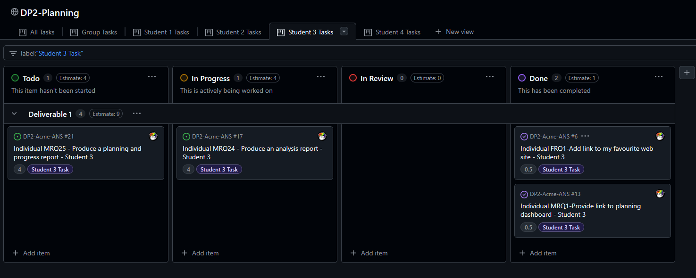

Figure 1 - Student 3 Tasks view on GitHub Project

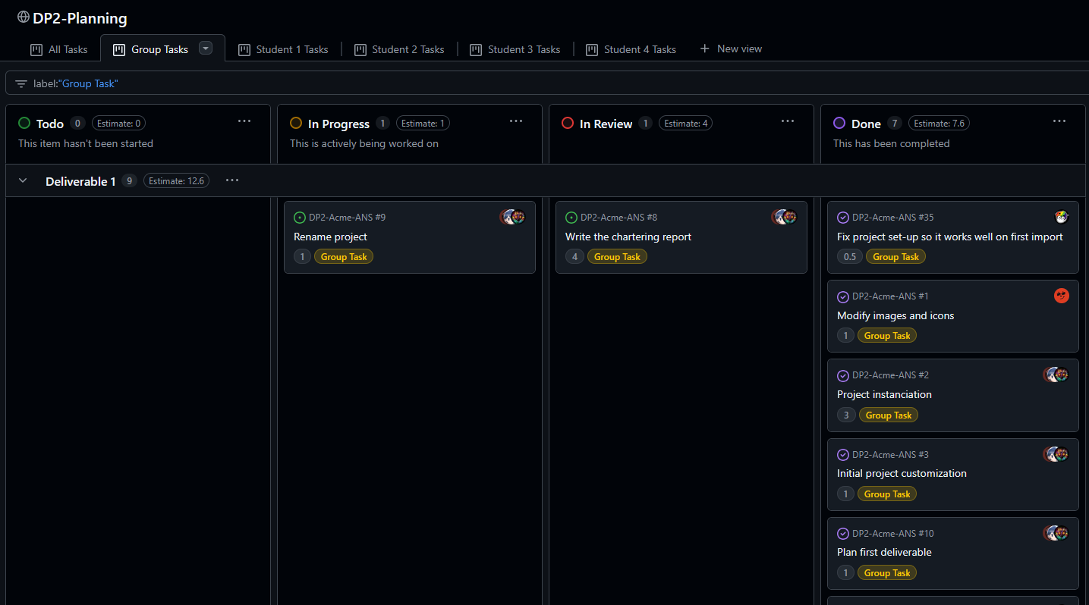

Figure 2 - Group Tasks view on GitHub Project

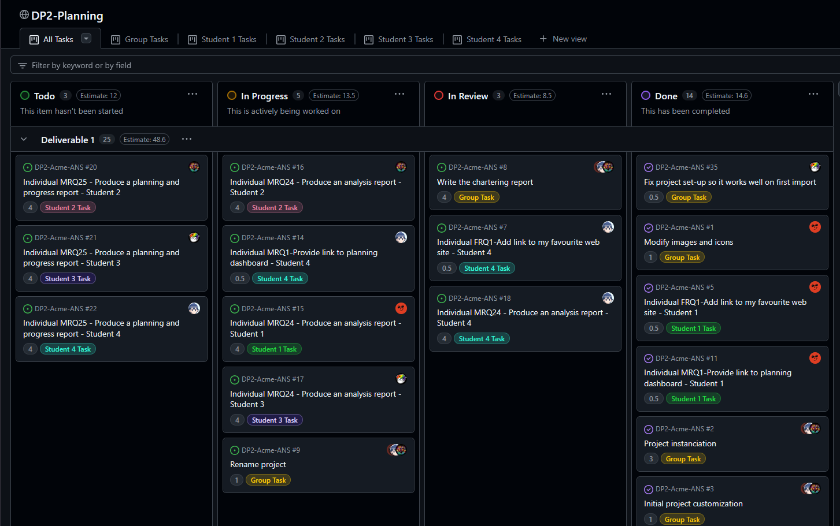

Figure 3 - All Tasks view on GitHub Project

# Conclusions

In conclusion, the document delivery and GitHub planning dashboard have been solved giving priority to cohesion and clarity. A standardized template was created for consistency, and a GitHub project was set up to effectively track and manage tasks. These measures align with project guidelines and enhance overall organization.

# Bibliography

Intentionally blank.